Parent Portal Update

There are a few new important updates about parent portal.

1. You can now reset your own password, by clicking the blue link on the sign in screen.

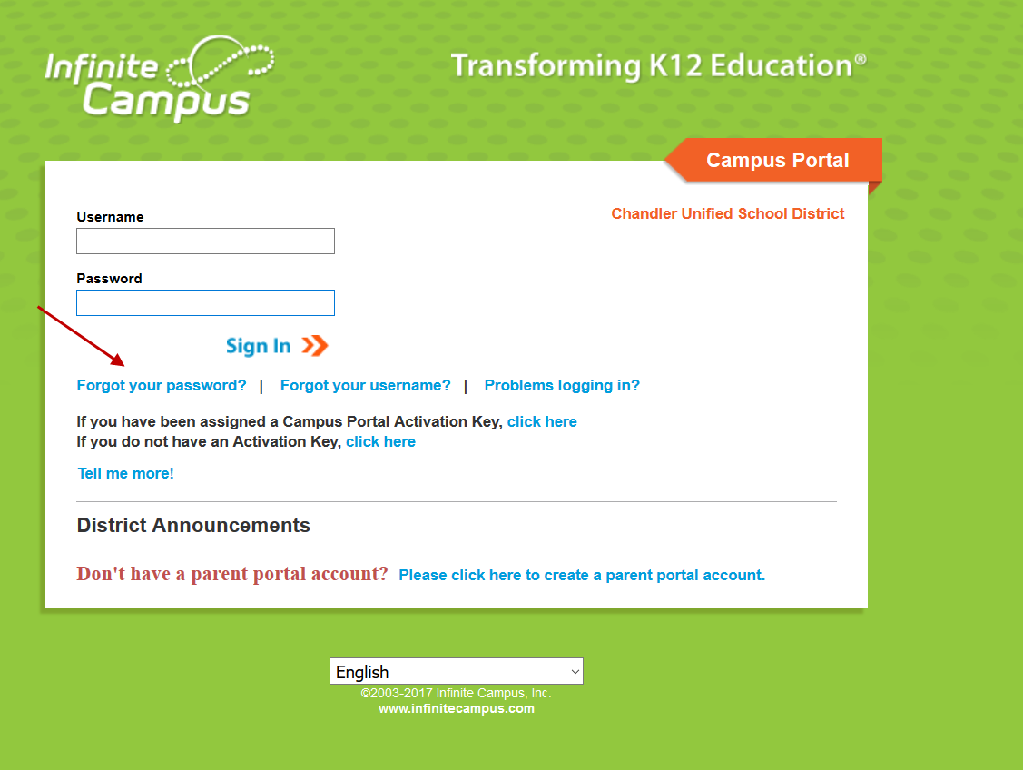

1. Did you know that you can pick a preferential language on the main screen?

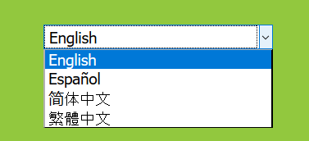

1. Account security email. When you initially log into IC, it will prompt you to enter in a security email. This can be any email where you would like to be notified if your account has been logged into from a different computer.

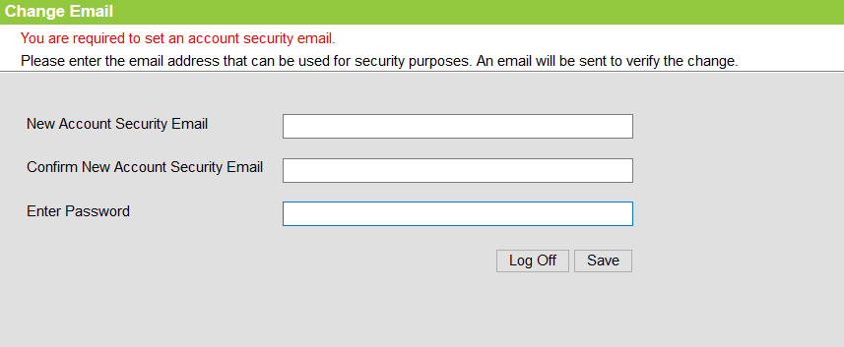

If you bypass this setting, you can always change your account settings in IC by clicking on Account Setting in the index and editing your security email.

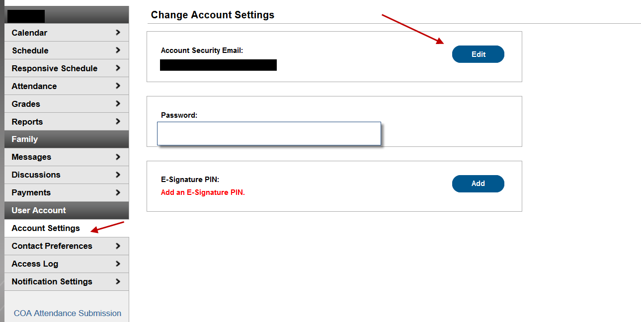

1. While you are in your account, it is important for you to go into the Contact Preferences if you would like to receive Messages from School Messenger in Spanish please choose your Preferred Language to Español and click Save.

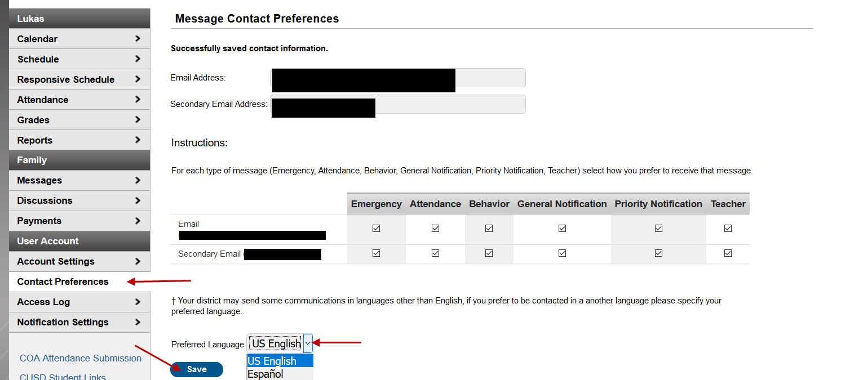

1. Step by step directions for changing your password:
   1. Click on Forgot your password?

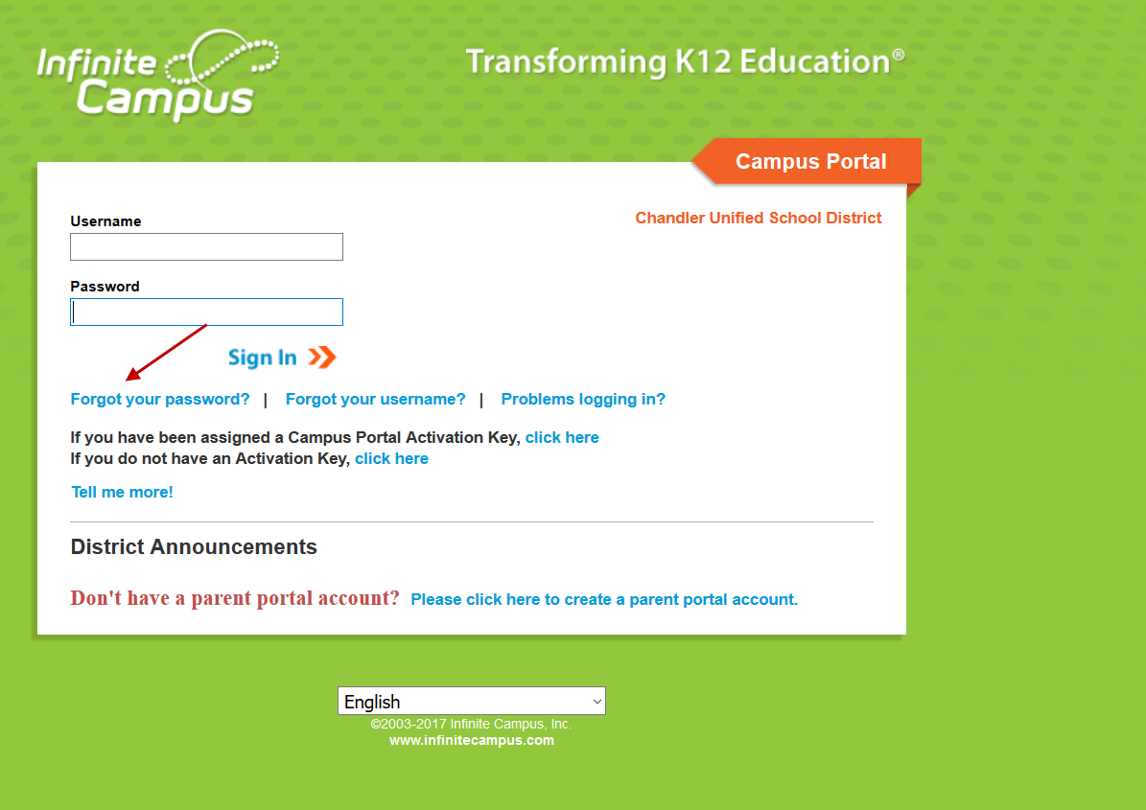

* 1. Enter your username

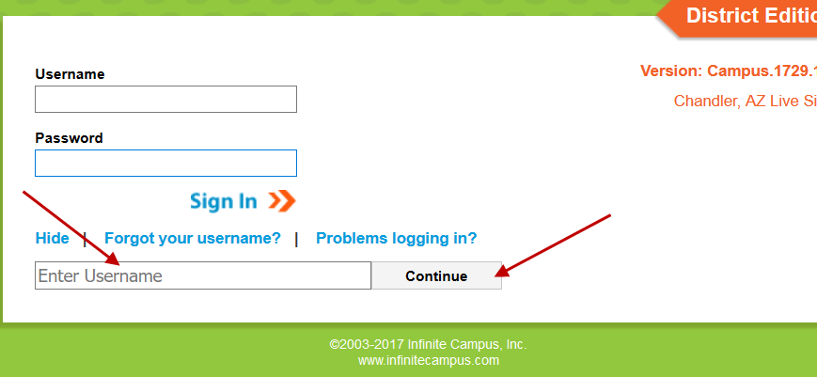

* 1. You will receive an email to the security email you set up and please click the link to reset your password.

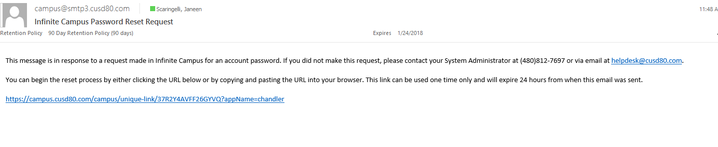

* 1. Type in a new password. Remember to use a combination of uppercase letters, lowercase letters, numbers and symbols to create a strong password.

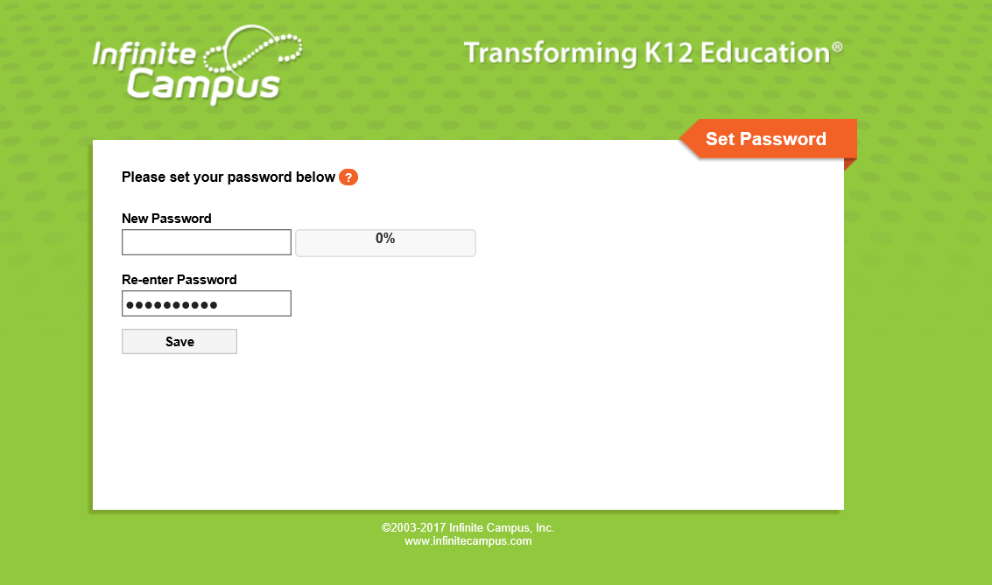

* 1. When you hit 100%, you have put in a strong password, please re-enter and click Save. This will bring you to the sign-in screen for you to log into your account.

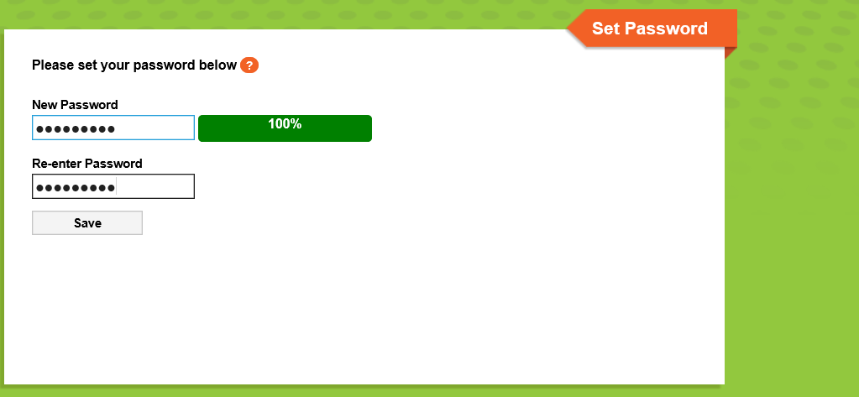

* 1. You will receive an email to your security email that you set up alerting you that you reset your password. If you are still having issues, please contact the portal manager at your child’s school. It is important that you start there first as they know your family.

